**Name : E W V Pesara**

**ID : 26708**

**JavaScript - Tutorial**

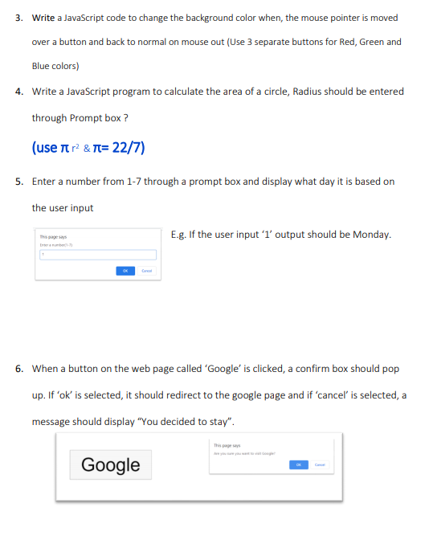

**WEB TUTE 08**

Exercise 03

<html>

<head>

<title>Background Color Change</title>

<link href=”tut.css”rel=”stylesheet”>

</head>

<body>

<button id="redButton" onmouseover="changeColor('red')" onmouseout="resetColor()">Red</button>

<button id="greenButton" onmouseover="changeColor('green')" onmouseout="resetColor()">Green</button>

<button id="blueButton" onmouseover="changeColor('blue')" onmouseout="resetColor()">Blue</button>

<script>

function changeColor(color)

{

document.body.style.backgroundColor = color;

}

function resetColor() {

document.body.style.backgroundColor = '';

}

</script>

</body>

</html>

**CSS FILE**

button {

padding: 10px;

font-size: 16px;

cursor: pointer;

}

**Exercise 04**

<html>

<head>

<title>Circle Area Calculator</title>

<link href=”tut.css” rel=”stylesheet”>

</head>

<body>

<script>

function calculateCircleArea()

{

var radius = parseFloat(prompt("Enter the radius of the circle:"));

if (isNaN(radius)) {

alert("Invalid input! Please enter a valid number.");

return;

}

var pi = 22 / 7;

var area = pi * radius * radius;

alert("The area of the circle with radius " + radius + " is: " + area.toFixed(2));

}

calculateCircleArea();

</script>

</body>

</html>